SESSION 10 ASSIGNMENT 2

Problem: Implement the concept given in below blog link and share the complete steps along with

screenshots.

<https://acadgild.com/blog/loading-data-into-hbase-using-pig-scripts/>

Soln:

Hadoop fs -put ‘/home/acadgild/student.txt’ student.txt

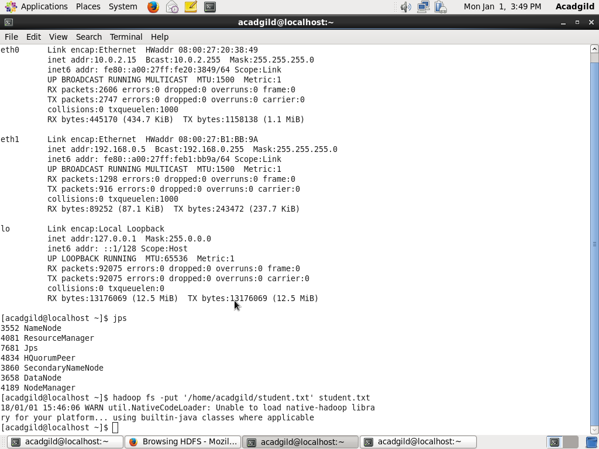

Start-hbase.sh

Hbase shell

Create ‘studentacad’,’student_data’

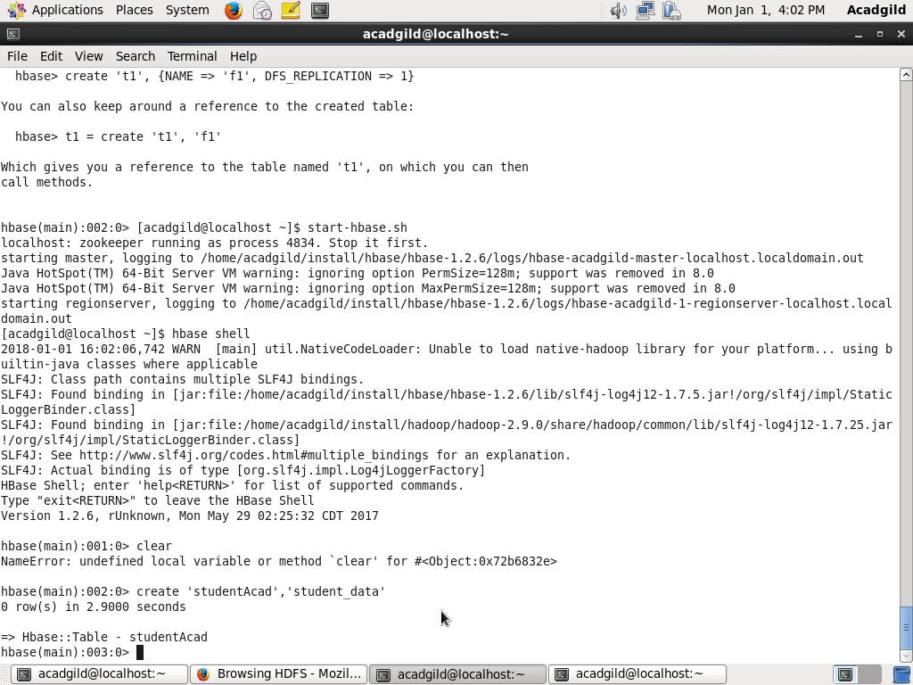

rawData=LOAD ‘student.txt’ USING PigStorage(‘,’) AS (StudentName:chararray,sector:chararray,DOB:chararray,qualification:chararray,score:int,state:chararray,randomName:chararray);

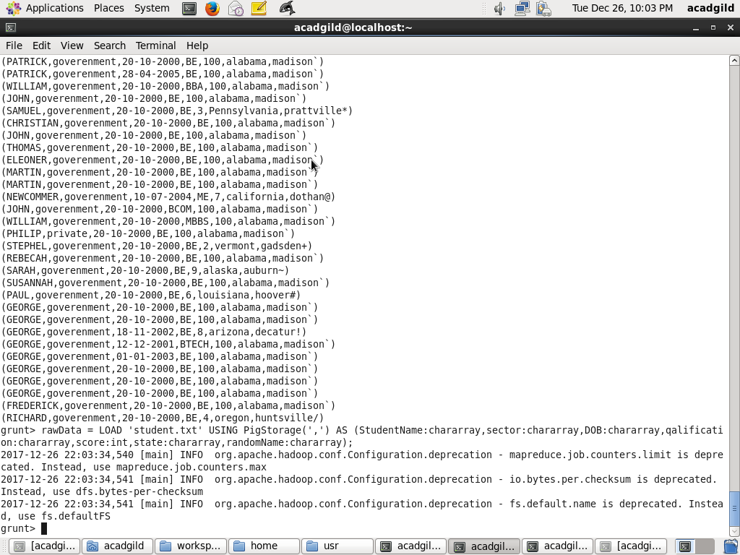

STORE rawData INTO ‘hbase://studentacad’ USING org.apache.pig.backend.hadoop.hbase.HbaseStorage(‘student_data:StudentName, student_data:sector, student_data:DOB, student_data:qualification, student_data:score, student_data:state, student_data:randomName’);

